**Customerid=1**

**First name =jasmitha**

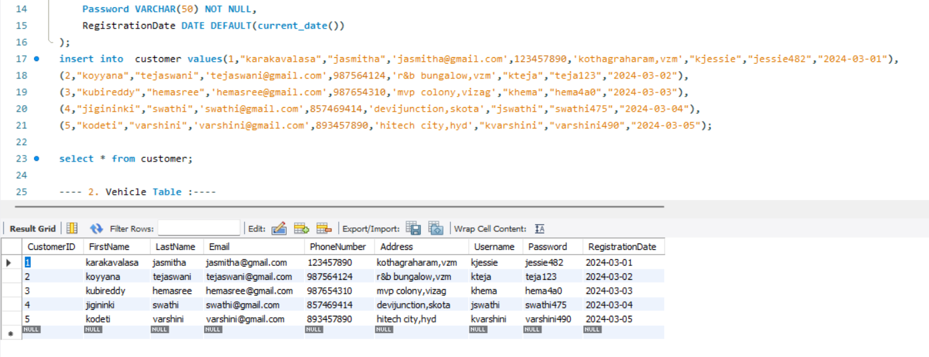

**Vehicleid=100**

**Vehicle model=New NEXA Baleno**

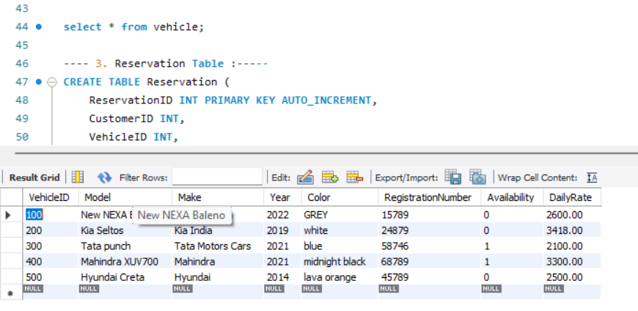

**Now Jasmitha with customerid=1 reservation the vehicle with vehicleid=100 and**

**the model = New NEXA Baleno.**

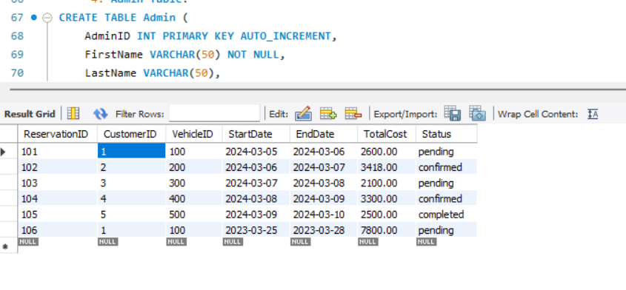

**Console window:**

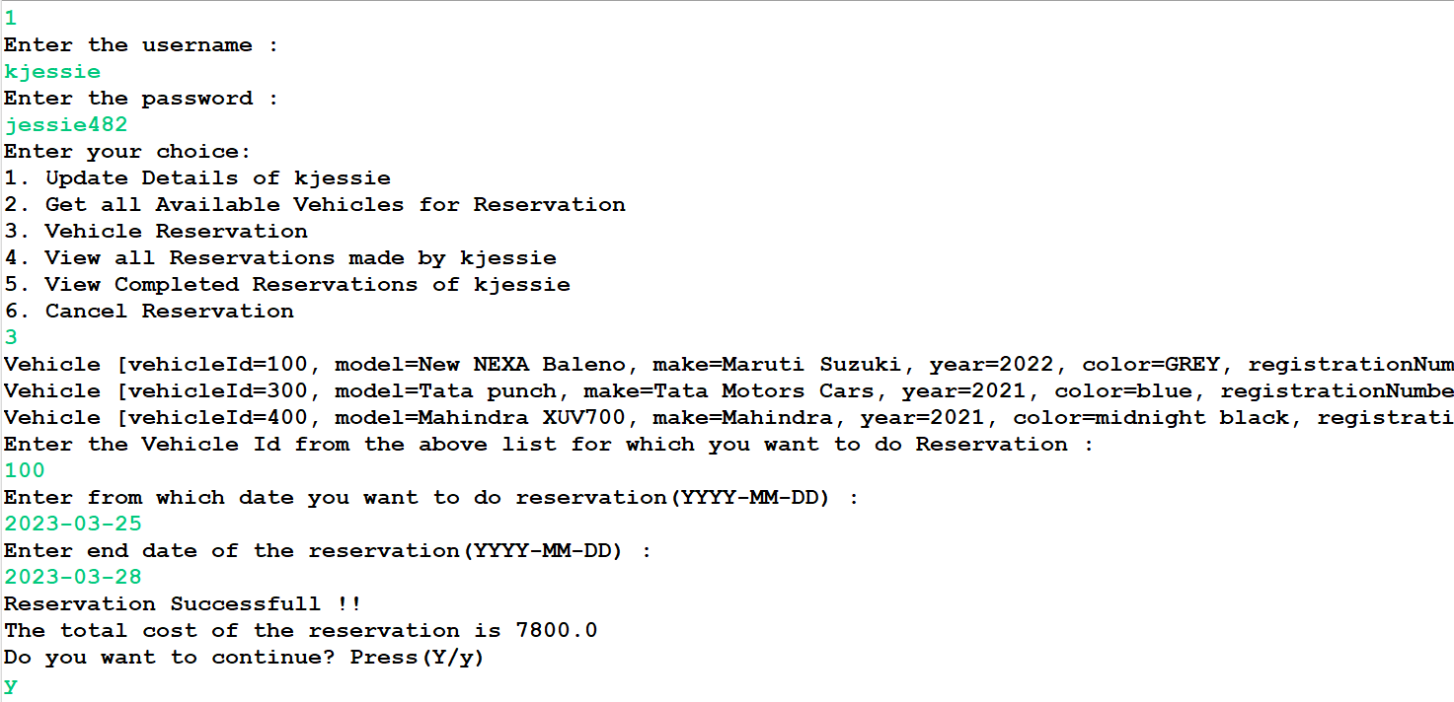

**Here,we can see the customer id =1 reserved the vehicleid=1,and the same thing is reflected in the data base**